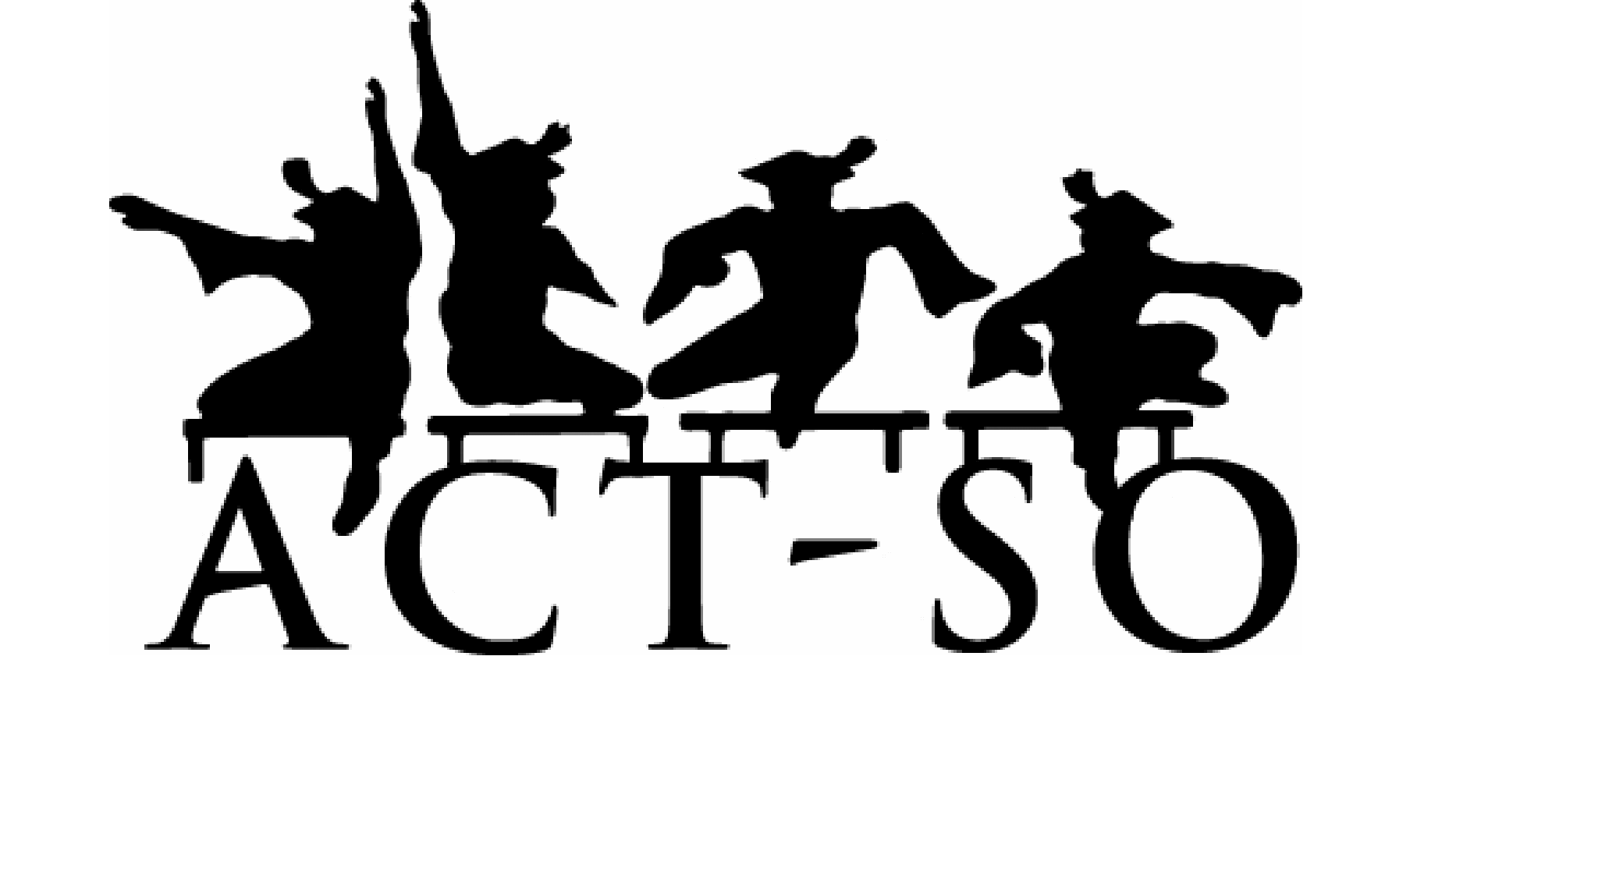
ACADEMIC COMPETITION FOR AUSTIN-AREA
HIGH SCHOOL STUDENTS
SATURDAY  APRIL 7, 2018 | 12 NOON | GEORGE WASHINGTON CARVER MUSEUM  1165 ANGELINA ST.  AUSTIN TEXAS 78702

Applications due by April 1
Writings deadline March 30
31 competition categories including:
STEM
HUMANITIES
PERFORMING ARTS
VISUAL ARTS
BUSINESS
Must participate to qualify for all expense paid to nationals!!!!

(Your school projects and performances can be entered)

Contact: Melinda Walker ericsnina8@hotmail.com 512-293-6554

Please support our area youth by attending this free event.

